Lab 2

DEBUG IN SIMULATION (Running the lab in simulation mode) (40 Points)

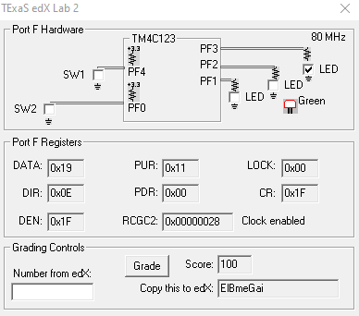

DEBUG ON THE REAL BOARD (Running the lab on the real board) (40 Points)
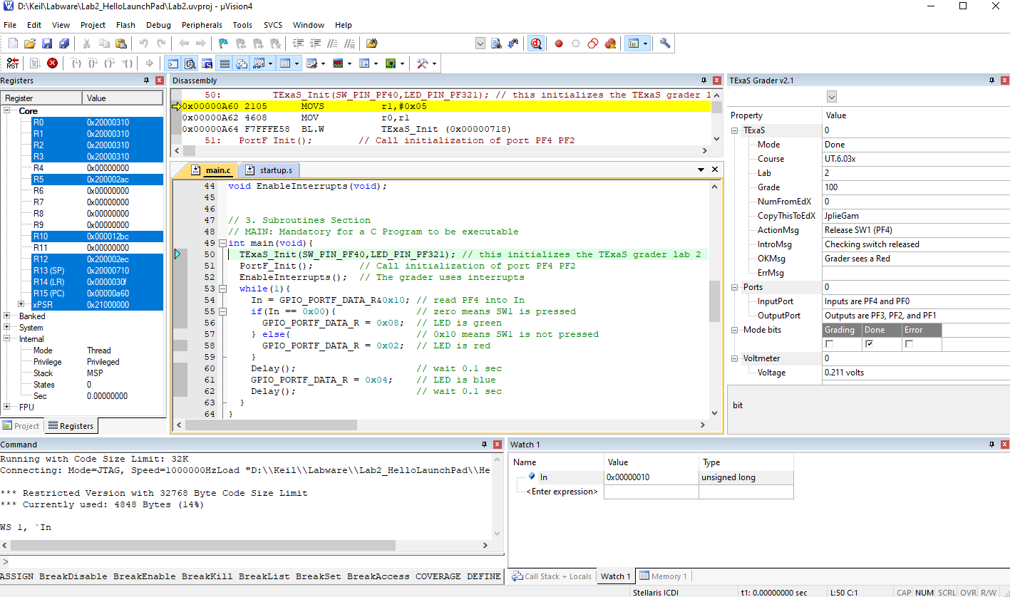

QUESTIONS (20 Points)

1) Find a shortcut button for performing the Build Target step. (Step 3 above) (10 Points)

F7

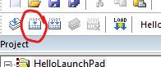

2) Find a shortcut button to start/stop the Debugger. (10 Points)

Ctrl + F5

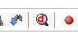

INTERESTING QUESTIONS
Things to think about but NOT implement in your lab:
1) How could you make the LED flash slower?
Increase the delay

2) How could you make the LED flash blue-yellow instead of blue-red?
yellow RG- 0x0A
while(1){
In = GPIO_PORTF_DATA_R&0x10; // read PF4 into In
if(In == 0x00){ // zero means SW1 is pressed
GPIO_PORTF_DATA_R = 0x08; // LED is green
} else{ // 0x10 means SW1 is not pressed
GPIO_PORTF_DATA_R = 0x0A; // LED is yellow
}
Delay(); // wait 0.1 sec
GPIO_PORTF_DATA_R = 0x04; // LED is blue
Delay(); // wait 0.1 sec
}
}

